IdeationPhase Define the
Problem Statements
Date | 13 February 2026
TeamID | LTVIP2026TMIDS26598
Project Name | Prevent User Deletion if Assigned to Incident
Maximum Marks | 2 Marks

Customer Problem Statement Template:
This project helps ServiceNow administrators maintain data integrity by preventing accidental deletion of users who are assigned to active incidents. Using a Before Delete Business Rule, the system checks incident records and blocks deletion if the user is linked to one or more incidents, ensuring workflow continuity and system stability.

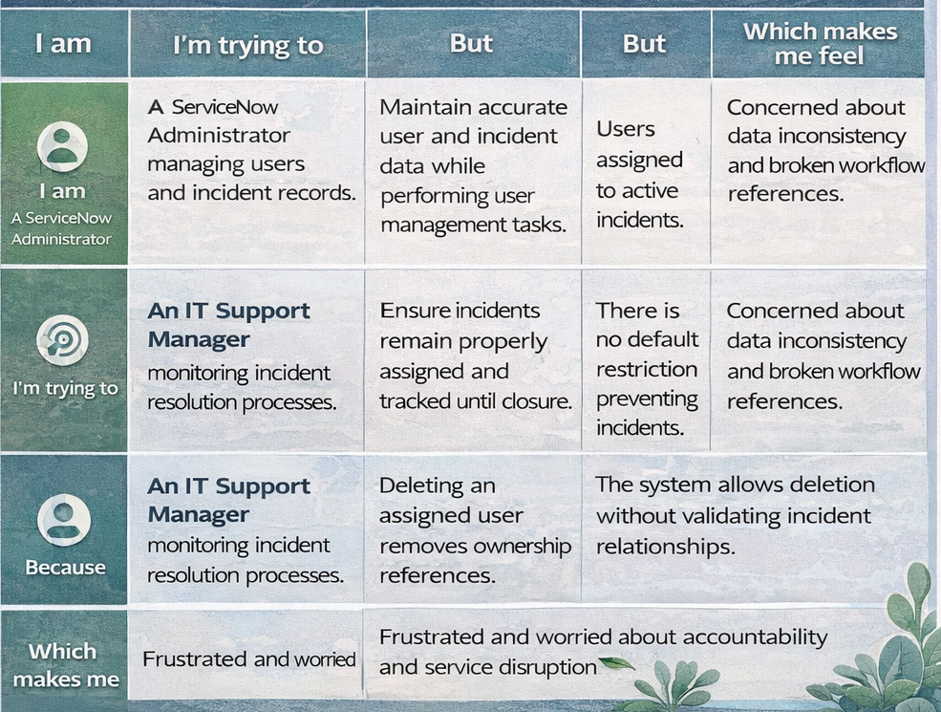

Reference: https://miro.com/templates/customer-problem-statement/
Example:

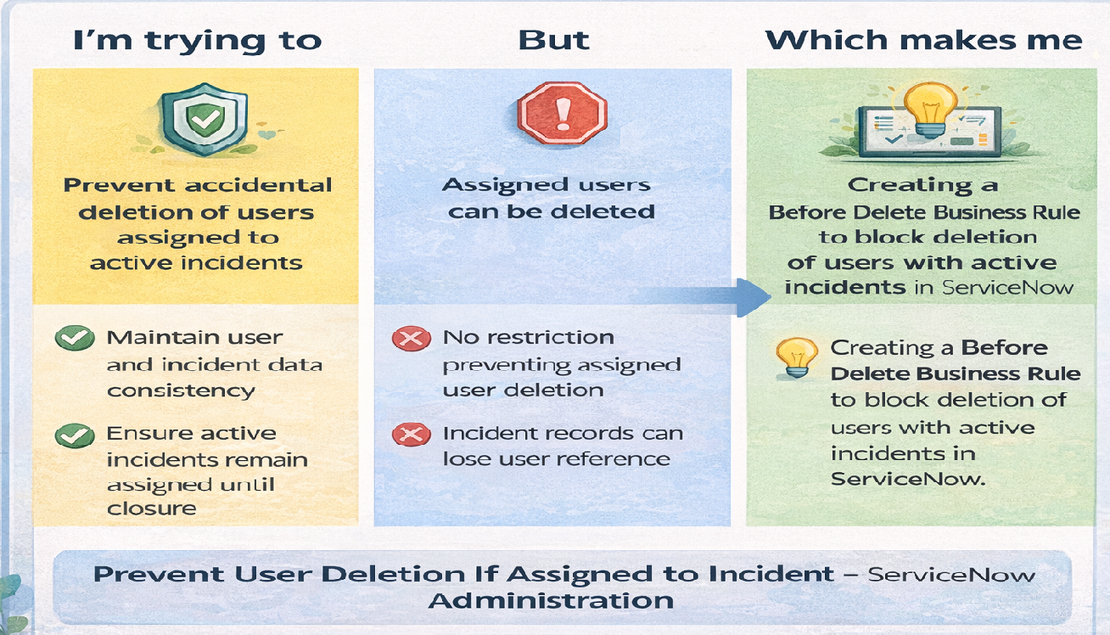

Problem  Statement(PS) | I am  (Customer) | I’m trying to | But | Because | Which makes me  feel
PS-1 | A ServiceNow Administrator managing users and incident records. | Maintain accurate user and incident data while performing user management tasks. | Users assigned to active incidents can be accidentally deleted. | There is no default restriction preventing deletion of assigned users in the system. | Concerned about data inconsistency and broken workflow references.
PS-2 | An IT Support Manager monitoring incident resolution processes. | Ensure incidents remain properly assigned and tracked until closure | Deleting an assigned user removes ownership references from incidents. | The system allows deletion without validating incident relationships. | Frustrated and worried about accountability and service disruption.

